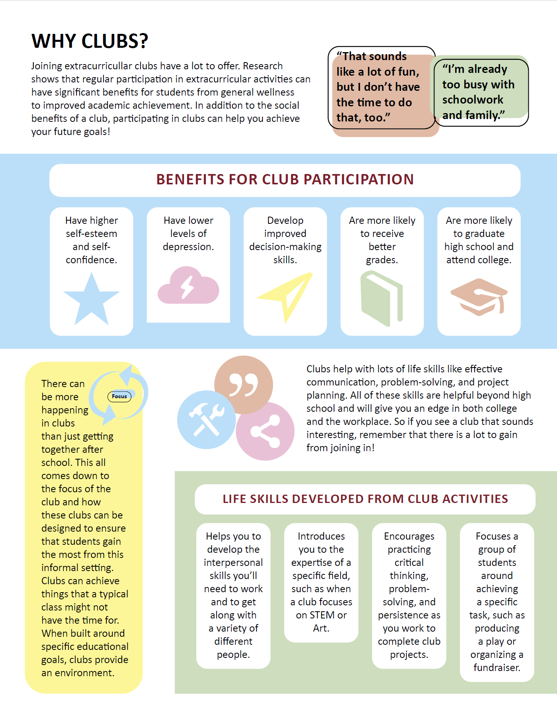CLUBs INFOGRAPHIC