Below are two X-ray pictures of lungs. What differences do you notice between the two pictures? Please write your responses beside the pictures.
X-ray 1:
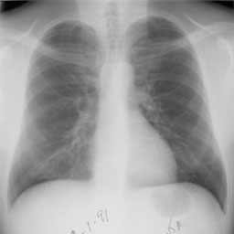
Explanation:

X- ray 2:

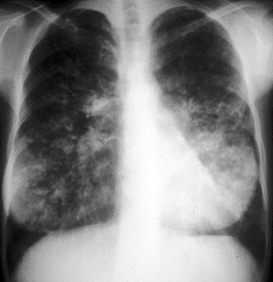
Explanation:

