ISTE Standard | Key Components | Tech that Supports this Standard | How can I implement this in my classroom?
1.1
Empowered Learner

1.2
Digital Citizenship

1.3
Knowledge Constructor

1.4
Innovative Designer

1.5 Computational Thinker

1.6
Creative Communicator

1.7
Global Collaborator

1.1  Empowered Learner | Chemix  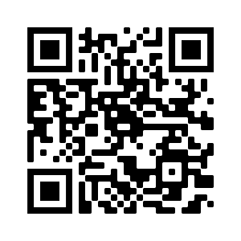 | Flip  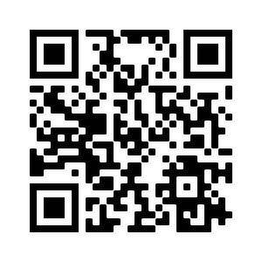
1.2  Digital Citizenship | Parlay  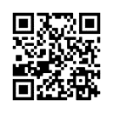 | Seesaw  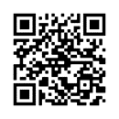
1.3  Knowledge Constructor | Pear Deck  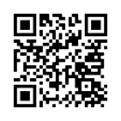 | Google Draw
1.4  Innovative Designer | Desmos  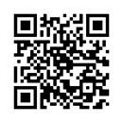 | Kahoot  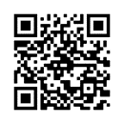
1.5  Computational Thinker | Blooket  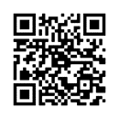 | Wakelet  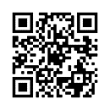
1.6  Creative Communicator | iMovie  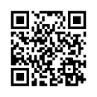 | Mentimeter  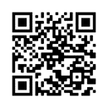
1.7  Global Collaborator | Padlet  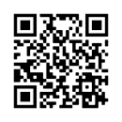 | Powtoon  